Customer Behaviour Analysis — Project Documentation

1. Project Overview
The project focuses on preparing a customer shopping behaviour dataset for analysis using Python, Pandas, NumPy, and PostgreSQL hosted on Supabase. The workflow includes data exploration, missing-value handling, data transformation, validation, and loading the processed dataset into a cloud database for further analysis and visualisation.
Tools and technologies used
- Python
- Google Colab
- Pandas and NumPy
- SQLAlchemy and psycopg2
- Supabase PostgreSQL

2. Dataset Description
The dataset, customer_shopping_behavior.csv, contains 3,900 records describing customer demographics, purchasing behaviour, product preferences, and shopping patterns.
Key attributes include:
- Customer ID, age, and gender
- Purchased items and product categories
- Purchase amount and location
- Product size, colour, and season
- Review ratings and subscription status
- Shipping type, discounts, and promo code usage
- Previous purchases and purchase frequency
Initially, the dataset contained 18 columns.

3. Data Exploration and Profiling
The dataset was loaded into a Pandas DataFrame in Google Colab.
Exploratory analysis was performed using:
- head() to inspect sample records.
- describe() to examine numerical statistics.
- info() to inspect column data types and non-null counts.
- describe(include='all') to examine both numerical and categorical attributes.
- isnull().sum() to identify missing values.
The initial profiling identified 37 missing values in the Review Rating column. Other columns had complete values.

4. Data Cleaning and Transformation

4.1 Handling Missing Values
Missing review ratings were filled using the median review rating of the corresponding product category. This preserved the existing ratings while imputing missing values using category-specific statistics.

4.2 Standardising Column Names
Column names were converted to lowercase and spaces were replaced with underscores to make them easier to reference in Python and SQL.
The column purchase_amount_(usd) was renamed to purchase_amount.

4.3 Creating Customer Age Groups
A new column, age_group, was created using pd.qcut() to divide customer ages into four quantile-based groups:
- Young Adult
- Adult
- Middle-aged
- Senior
This introduced an age-based segmentation attribute for subsequent analysis.

4.4 Transforming Purchase Frequency
A new column, purchase_frequency_days, was derived by mapping categorical purchase frequencies to numerical day intervals.
Examples include:
- Weekly: 7 days
- Fortnightly and Bi-Weekly: 14 days
- Monthly: 30 days
- Quarterly and Every 3 Months: 90 days
- Annually: 365 days
This transformation makes purchase frequency easier to analyse numerically.

4.5 Validating Redundant Columns
The values in discount_applied and promo_code_used were compared. The validation returned True, indicating that the two columns matched for all records.
Based on this result, promo_code_used was removed as a redundant column.

4.6 Duplicate and Data-Type Checks
The dataset was checked for duplicate rows using duplicated().sum(). The result was zero duplicate rows.
Column data types were also inspected to verify the resulting schema, including integer, floating-point, text, and categorical columns.

5. Connecting to Supabase PostgreSQL
The processed DataFrame was connected to a cloud PostgreSQL database hosted on Supabase.
The following libraries were used:
- SQLAlchemy for database connectivity and table operations.
- psycopg2 for PostgreSQL communication.
An SSL-enabled database connection was configured, and the connection was tested by retrieving the PostgreSQL server version.
The connection test succeeded, confirming connectivity to PostgreSQL 17.11.

6. Loading the Processed Dataset
The cleaned DataFrame was loaded into a PostgreSQL table named customer using Pandas to_sql().
The operation used if_exists='replace', which replaces an existing table with the new DataFrame contents if the table already exists.
The notebook confirmed that 3,900 rows were successfully loaded into the customer table.
The resulting table contains 19 columns: the original attributes after cleaning and renaming, plus the derived age_group and purchase_frequency_days columns, with promo_code_used removed.

7. Outcome
The notebook completed the following workflow:
- Loaded and profiled the customer shopping dataset.
- Identified and handled missing review ratings.
- Standardised column names and data types.
- Created age-group and purchase-frequency features.
- Validated redundant fields and checked duplicate records.
- Established a connection to Supabase PostgreSQL.
- Loaded all 3,900 processed records into the customer table.
The resulting database table is prepared for subsequent SQL analysis and Power BI reporting.
SQL ANALYSIS
--
purchase gender wise
select gender, sum(purchase_amount) from customer
group by gender;

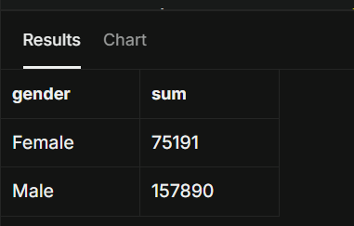
-- used discount but amt more than average purchase_amount

select customer_id,purchase_amount from customer
where discount_applied='Yes' and purchase_amount > (select avg(purchase_amount)from customer);
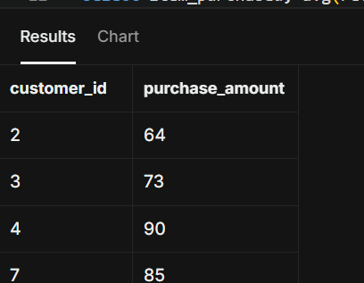

-- top 5 products with highest average review_rating

select item_purchased, avg(review_rating) from customer
group by item_purchased
order by avg(review_rating) desc limit 5;
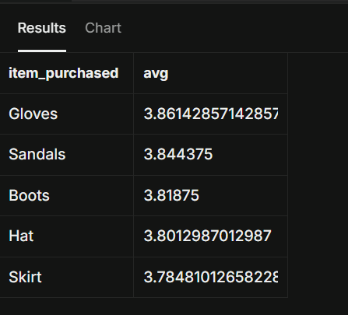

-- compare between shipping_type

select shipping_type, round(avg(purchase_amount),2)
from customer
where shipping_type in ('Express','Standard')
group by shipping_type;
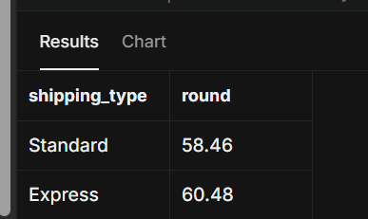

-- compare subscribers , non subscribers
select subscription_status,count(subscription_status), round(avg(purchase_amount),2), sum(purchase_amount)
from customer
group by subscription_status;
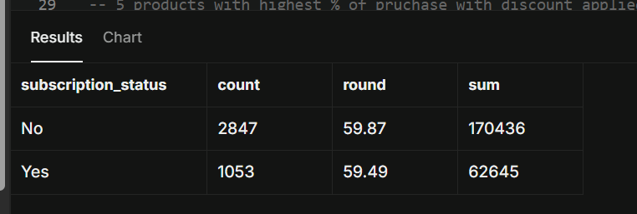

-- 5 products with highest % of pruchase with discount_applied

SELECT
item_purchased,
(ROUND(100*
SUM(CASE
WHEN discount_applied = 'Yes' THEN 1
ELSE 0
END) / COUNT(*),
2
))AS discount_rate
FROM customer
GROUP BY item_purchased
LIMIT 5;
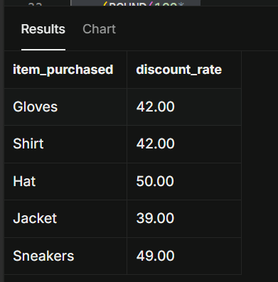
-- customer type

SELECT
CASE
WHEN previous_purchases <= 1 THEN 'new'
WHEN previous_purchases BETWEEN 2 AND 10 THEN 'returning'
ELSE 'loyal'
END AS customer_category,
COUNT(customer_id) AS customer_count
FROM customer
GROUP BY customer_category;
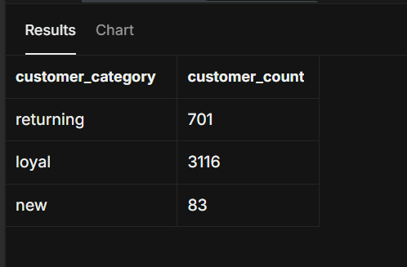
-- top 3 purchased within each category
--Q8. What are the top 3 most purchased products within each category?
WITH item_counts AS (
SELECT category,
item_purchased,
COUNT(customer_id) AS total_orders,
ROW_NUMBER() OVER (PARTITION BY category ORDER BY COUNT(customer_id) DESC) AS item_rank
FROM customer
GROUP BY category, item_purchased
)
SELECT item_rank,category, item_purchased, total_orders
FROM item_counts
WHERE item_rank <=3;
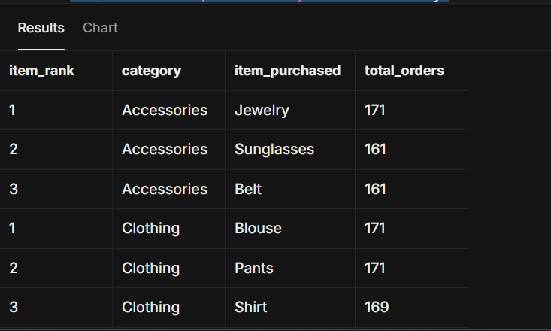
--Q9. Are customers who are repeat buyers (more than 5 previous purchases) also likely to subscribe?
SELECT subscription_status,
COUNT(customer_id) AS repeat_buyers
FROM customer
WHERE previous_purchases > 5
GROUP BY subscription_status;
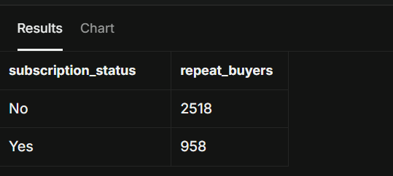

--Q10. What is the revenue contribution of each age group?
SELECT
age_group,
SUM(purchase_amount) AS total_revenue
FROM customer
GROUP BY age_group
ORDER BY total_revenue desc;

SELECT COUNT(*) AS total_rows
FROM public.customer;
